**Lab 04**

**Using Single Row Functions to Customize Output**

* Showing the table of flight

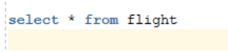

Output

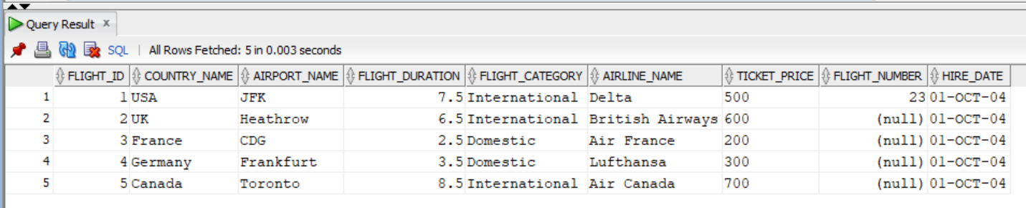

* **Activity 1:**

Use of Character Functions to Display Well-Formatted Results

1. **Display the job id for 'last_name' in a specific format:**

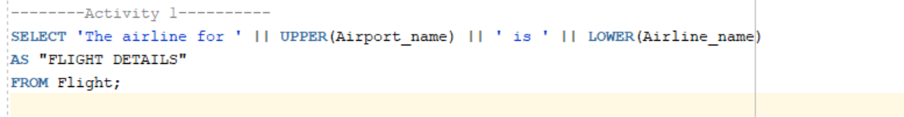

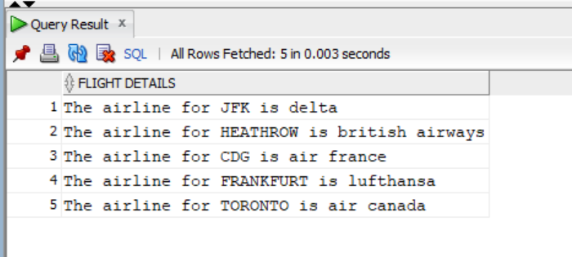Output:

1. **Display employee number, name, and department number for a specific employee:**

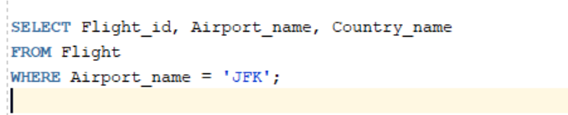

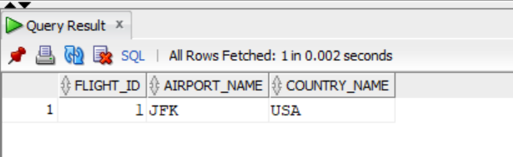

Output:

1. **Display first names and last names combined, length of last name, and position of letter "a":**

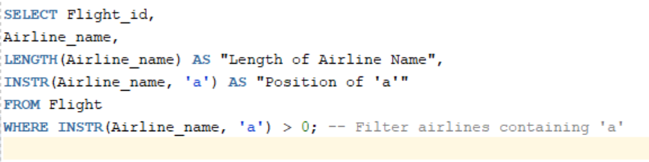

Output:

